Pass for level 9: W0mMhUcRRnG8dcghE4qvk3JA9lGt8nDl

Step 1: entering to natas8

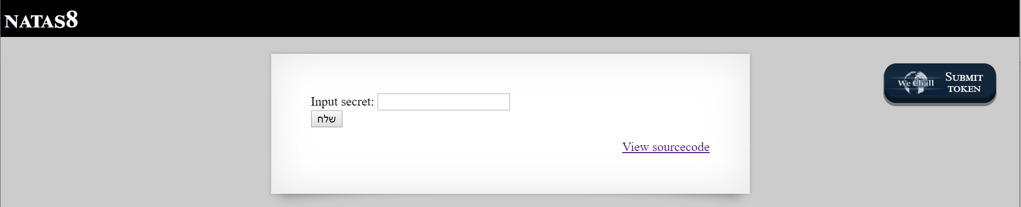

We see button and text input so we seek to see source code.

Step 2: Source code

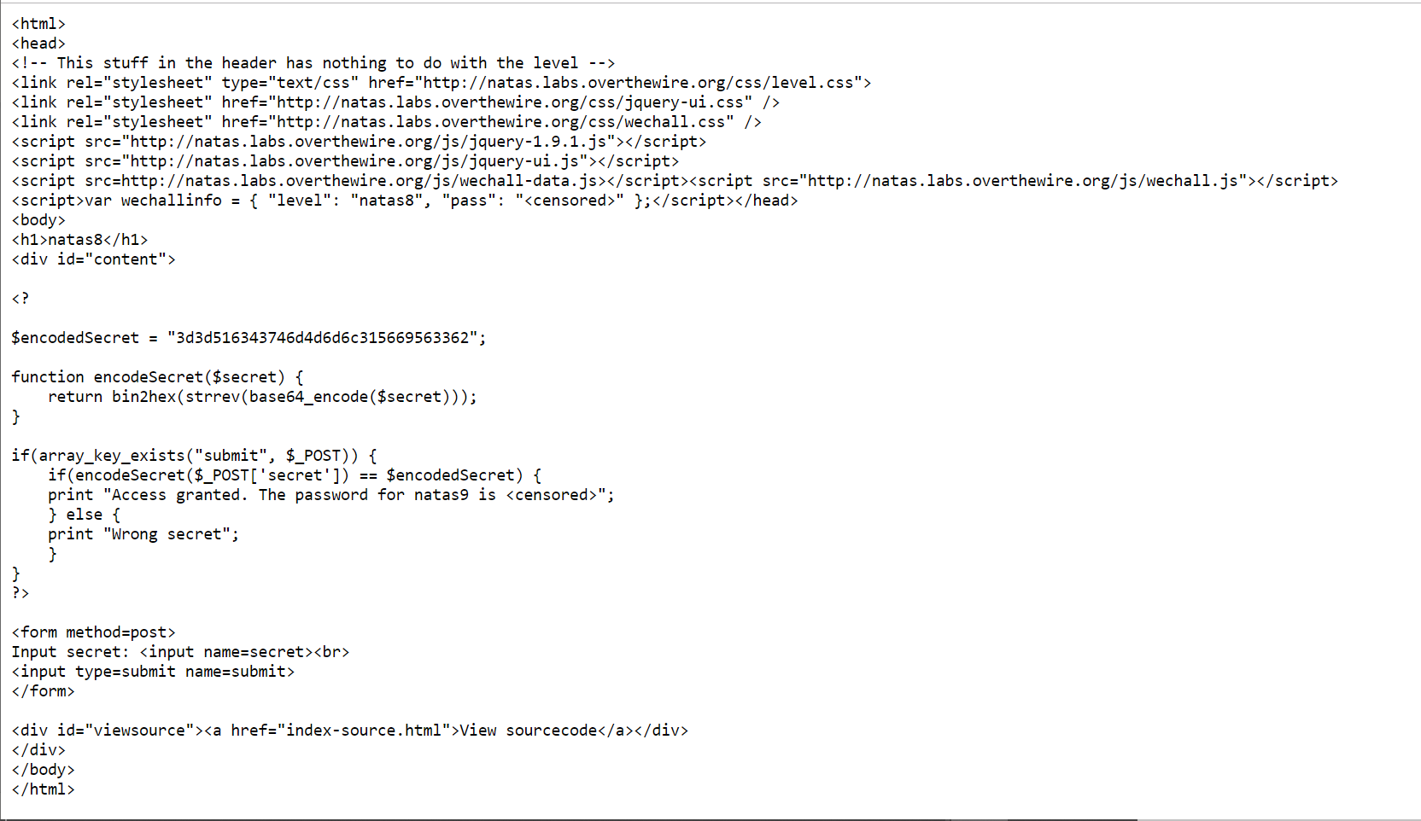

We see php code with code and encryptions so we created php code to decryption.

Step 3: Decryption code "level8.php"

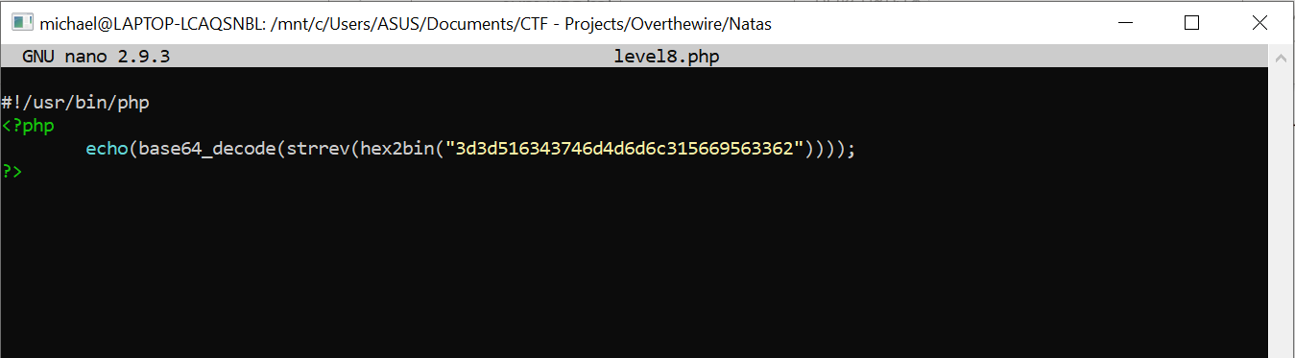



Step 4: code = oubWYf2kBq

Then we input that n the main page.

Step 5:

